Exporta Postal History can be Hard to Handle!

I believe that the Mexico Exporta series has all the challenges of 19 century postal history at a fraction of the cost. The Exportas were the regular series of Mexico issued from 1975-1993 and consisted of 30 Designs (regular, airmail, special delivery / entrega, insured / seguros). They were printed on 14 Papers (Series 1a-14a) Watermarked, Phosphorescence and Fluorescence (Yellow, White, Dull White, Reddish) and offer the collector Postal Stationery, Inverts, Perforation varieties, design differences, color varieties, essays, fixed Plate Flaws, and major Errors (bionicas printed on the non-phosphorescence side of the paper). Then factor in that most of the designs were reissued in higher denominations as the rates increased, and you have easily 300 different stamps to obtain.

Collecting the stamps is challenging enough, but if you are up for a real effort, try collecting the series on cover. Given that the postal rates changed 20 times during the Exporta era, and given the number of different designs and denominations that were used, you can assume that just collecting covers with each stamp would be tough enough. This article is going to take that challenge to the next level and give you 10 (some almost impossible) tough objectives in collecting the Exporta series on cover. Some of them surprised me and will surprise you too!

And I am not going to include the Bionic Bull or Bicycle.

#1. Tough Issues. Some of the issues are just very hard to find on cover. My list would include the 5c Steel Tubes, 5.60p Cotton, 10p Cattle, 50p Cotton, 1900p Abulon, 3600p Automotive Parts, 3900p Petroleum Valves, 4800p Tomato (both invert and normal), and 7200p Film. For each of those nine stamps, I found less than 10 undamaged covers out of the 20,000+ IYS correspondence.

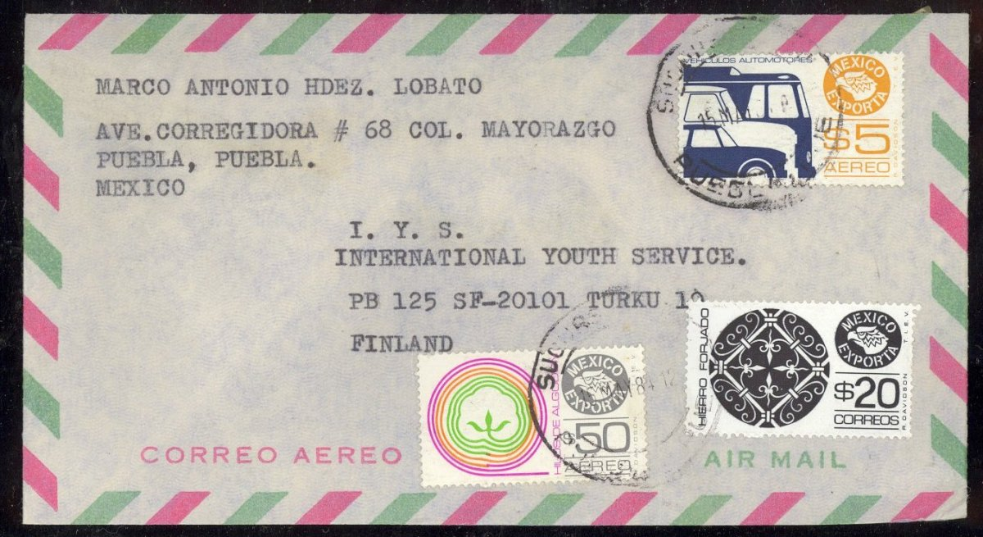

75p pays T35 1x rate on this 15 May 84 cover using the hard to find 50p Cotton.

#2 Postal Stationery and Seguros. I am not that big a fan of postal stationery. Until they become part of the hunt, that is. It turns out there are a number of varieties of the 80c and 1.60p sobres. I am still looking for the variety of the 80c which depicts a larger cattle at the left of the envelope. The 14p and 300p are very hard to find. Even more elusive are the 14p, 22p and 150p sobres. Peter Bamert is doing a Catalog and Reference work for Postal Stationery of Mexico, and he first put me on to the 22p and 150p. It turns out that one of what I thought was a 14p sobre with stamps covering it, was actually a 22p when I lifted the stamp. Lots of PSEs get used as just envelopes. But try finding a correctly rated cover which uses the value of the PSE to pay for the postage. That is a challenge.

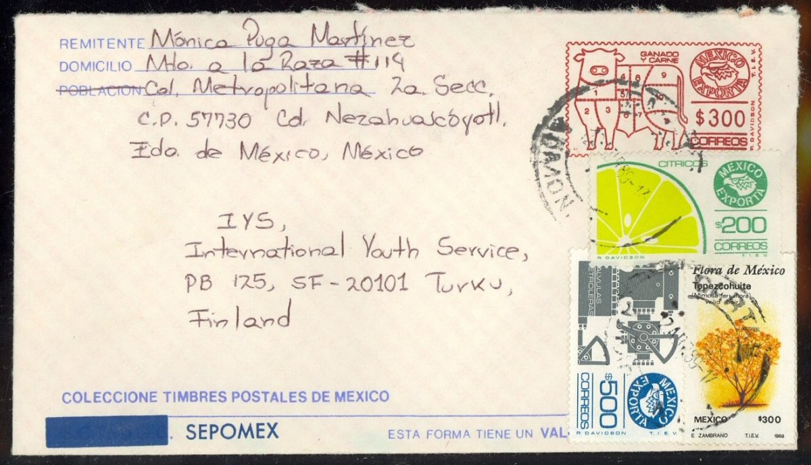
1300p pays 1x rate using 300p sobre for postage!
The seguros (insurance stamps) are considered part of the Exporta series. They were printed on papers 1 and 5 in denominations from 40c to 100p. They are supposed to be used for insurance, but with one exception, I have only found them used for postage. To find a correctly used seguros, you would have to find a cover where the non-seguros stamps paid a correct rate and the seguros stamps were extra. I have only one such cover.

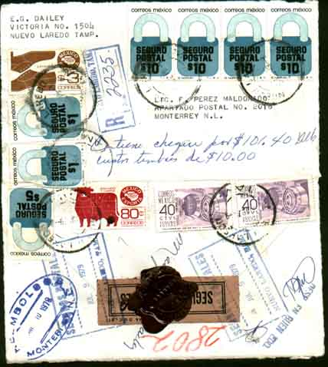

80c! plus 3p pays the domestic registered T29 rate within Mexico. 47.8p in Seguro Postal stamps pays insurance for $101.40 sent in cash. Lots of great auxiliary markings, opened for display. Sent from a stamp collector to a stamp dealer to pay a bill.

I have found all the other seguros denominations on cover, except one, the 40c seguro postal. I have found both the bionic bull and the bionic bicycle on cover, but am still looking for the 40c seguros on cover!

#3. Plate Flaws on Cover. Not everyone want to “fly speck”, but many of the plate flaws are fun to find. They are readily available as stamps on ebay, delcampe or in the MESPI circuit books. I have bought a cover with the 450p “R” in correos plate flaw and have a “trident” 80c Ganado where there is a flaw that makes the “Y” look like a trident. I looked for plate flaws in the IYS correspondence, especially looking for the “R” in correos and the “trident”, but maybe because there were not that many 80c stamps used to Finland, I did not find any plate flaws at all until I found this different one. Note: Later I found a few more, so far the cracked pipeand the spot next to the beak of the 20p Iron.

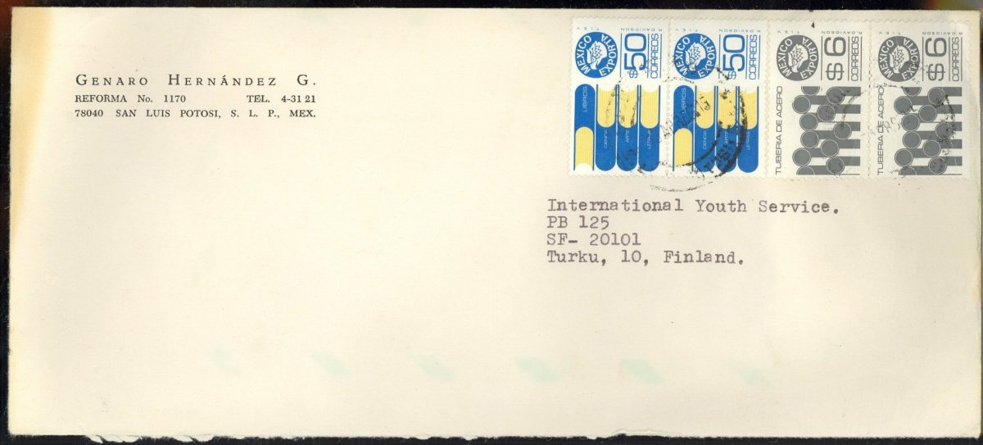

112p overpays T39 110p 1x rate. 6p has cracked pipe plate flaw. So far only the first plate flaw found in IYS correspondence.

I wonder if plate flaws on cover are created mostly by stamp dealers. But I really didn’t want you to get distracted by the stamps, PSE or errors. The real challenges of the Exportas are related to the rates.
#4. Short Rate Periods. The Exporta stamps were used over 20 different postal rate periods. These are called Tariffs. The Tariffs and their effective dates are shown in the following chart. Mexico is known for its inflationary period during this time. Postal rates did change 20 times from 1975-1990, going from 1.6p to 2500p (the US rate), so that is major increase. There is more to this though. While the inflation rate for everyday items increased 1000%, the postal rates increased much more, from between 1500% to 6000% (source Jorge A. Wise, Banxico, Sepomex, Banamex, Scott).

The end result of the inflationary period is 20 different postal rates. The challenge is to find correctly rated covers in each of those time periods. Some of the Tariffs were very short. There were 6 Tariffs that were 4 months or less. The shortest is T32.

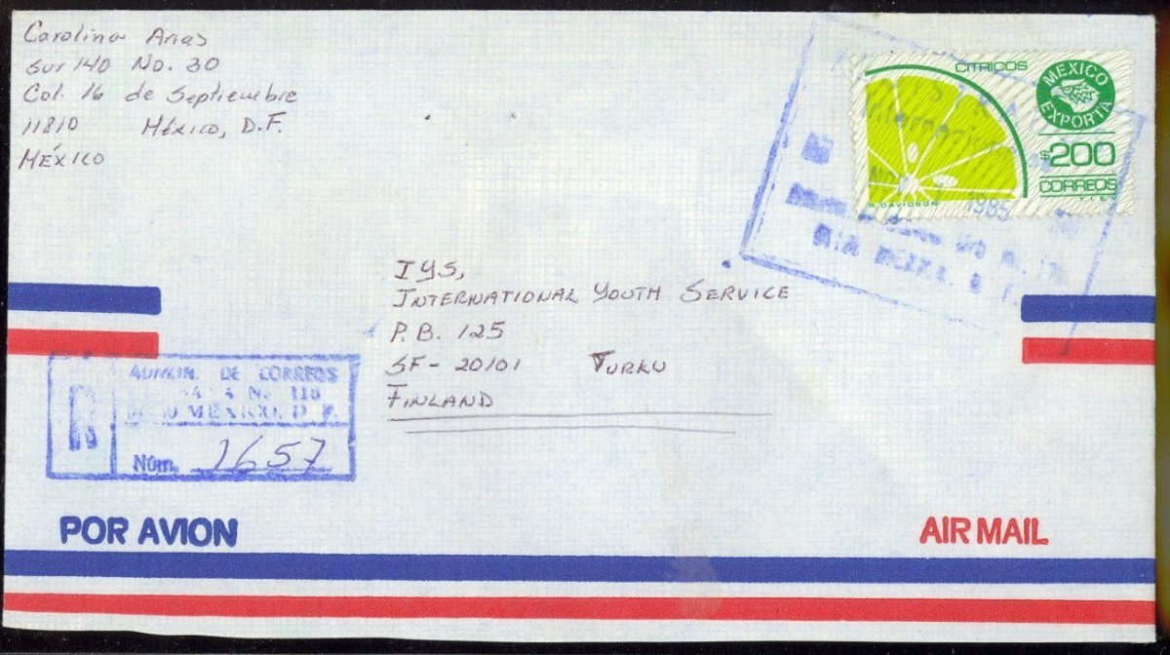

200p pays 1x Registered rate on T38 first day of rate!

#5. Early Uses. You can find some First Day of Issue covers on eBay and from dealers. I have some of them. However, I urge caution, it seems like an area of buyer beware. In looking at some of the covers I purchased I noticed a sloppy postmark of Abril 75? It must be a fake.

Here is the challenge. In looking through the books and sources on line, there does not seem to be a record of the first date of issue of each of the designs, much less when they were reissued on different papers. One book I have lists the general month/year that SEPOMEX ordered the stamps, and the general month/year that they should have first been available at the post office, but no definitive list of date of issue of each.

Some of the legitimate looking FDCs have a date of Nov 28 75 and others have a date of Set 15 82, but it looks like the only recourse is the brute force Earliest Known Use method of building a census of early use covers. Most certainly this would be necessary to find early uses where different paper types are used for the same denomination. Using the IYS correspondence, I am attempting to do just that. I welcome anyone that would like to compare their covers with what I have posted at my web site to come up with at least a general idea of when each issue became available.

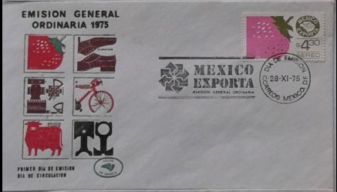

4.30p Fresa on Dia de Emision Nov 28 75 cover.

Finding first and last dates of Tariffs are a little easier, at least in the sense that you know the dates. But it often took a while for people and even the post office to use the correct rate. You would think that a registered cover rated by the post office would pay the correct rate, but that is most often not the case during the early days of the rate. In some periods it is almost a month before I can find a correctly rated registered cover using the new rates. In T30, I have 2 covers posted on the first day of rate – both using the T29 rates. The earliest correctly rated T30 cover I have is Jun 28 almost a month into the period.

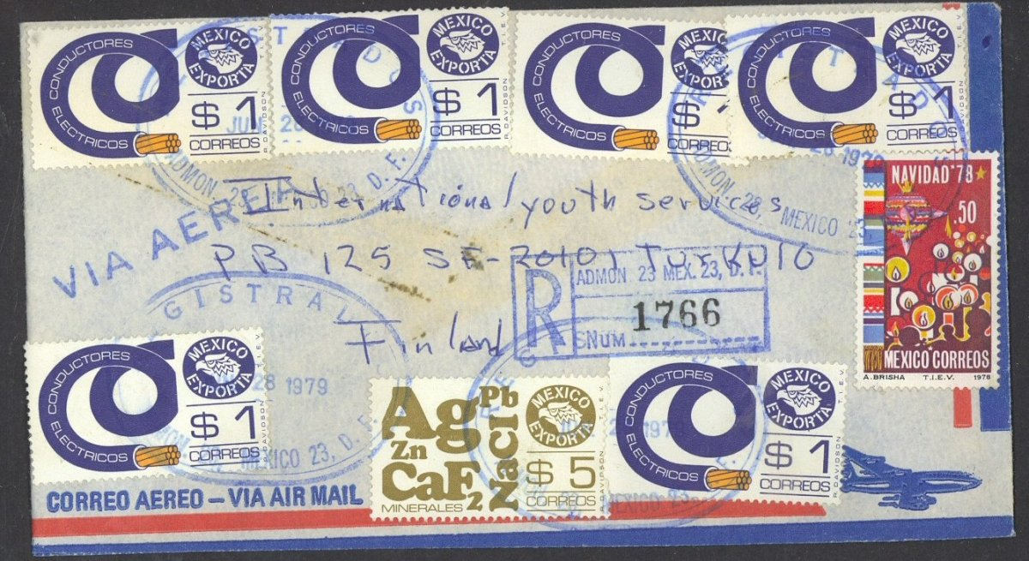

1st IYS use of 5p minerales. 11.5p pays 1x registered rate! This is the earliest correctly rate T30 cover I found in the IYS correspondence.

Also consider that the effective dates often fell on a Sunday – actually 4 times! Oddly, T46 starts on the day after Christmas. My understanding from a contributor to this article, is that in the smaller cities, if there is a market on Sunday, it is very likely that the post office is open. In the larger cities, the post office would not be open on Sunday. So a Sunday postmark could be legit, or it could just be a date cancel that was not advanced correctly.

#6. The hard rates (Restricted Delivery, Return Receipt and Surface Mail). For the next section, I am going to have to introduce a table of the other rates. Finding international mail to the US or Europe is not so hard. Registered mail is also not so hard. Where it gets tough is finding covers with restricted delivery or return receipt and surface mail. Combine these and you get some pretty tough combos. Try finding a cover sent surface registered.

Exporta Rate Tables for Europe from T29 through T50
Tariff | Effective | Months | Airmail | Reg | Reg² | AR | Surface | Postcard
T29 | Mon Dec 2 74 | 54 | 4.3 | 3 |  | 3 | 2.3 | 1.5
T30 | Mon June 11 79 | 19 | 5.5 | 6 |  | 4 | 3 | 2
T31 | Thu Jan 1 81 | 21 | 7 | 10 |  | 5 | 4 | 2.5
T32 | Sat Oct 9 82 | 2.7 | 14 | 20 |  | 10 | 8 | 5
T33 | Sat Jan 1 83 | 6 | 16 | 35 |  | 25 | 13 | 9
T34 | Fri July 1 83 | 6 | 24 | 50 |  | 35 | 19 | 13
T35 | Sun Jan 1 84 | 7 | 75 | 50 |  | 50 | 19 | R
T36 | Wed Aug 1 84 | 6 | 90 | 60 |  | 60 | 23 | R
T37 | Fri Feb 1 85 | 9 | 90 | 90 | 115 | 90 | 35 | R
T38 | Fri Nov 1 85 | 3 | 90 | 110 | 140 | 110 | 40 | R
T39 | Sat Feb 1 86 | 8 | 110 | 170 | 215 | 170 | 65 | R
T40 | Wed Oct 1 86 | 4 | 140 | 200 | 255 | 200 | 80 | R
T41 | Sun Feb 1 87 | 4 | 310 | 500 | 640 | 500 | 200 | R
T41A | Mon Jun 1 87 | 4 | 470 | 500 | 640 | 500 | 270 | R
T42 | Thu Oct 1 87 | 3 | 600 | 750 | 960 | 750 | 340 | R
T43 | Fri Jan 1 88 | 12 | 1000 | 1400 | 1800 | 1400 | 650 | R
T44 | Sun Jan 1 89 | 12 | 1300 | 2100 | 2700 | 2100 | 950 | R
T45 | Thur Feb 1 90 | 13 | 1700 | 3100 | 4000 | 3100 | 1400 | 1200
T46 | Wed Dec 26 90 | 11 | 2500 | 4000 | 5000 | 3900 | 1900 | 1800
T47 | Sun Dec 1 91 | 14 | 2500 | 4800 | 6000 | 3900 | 1900 | 1800
T48 | Wed Jan 27 93 | 26 | 2.5 | 4.8 | 6 | 3.9 | 1.9 | 1.8
T49 | Sat Apr 1 95 | 46 | 3.4 | 6.5 | 8.1 | 3.9 | 2.6 | 2.4
T50 | Mon Feb 1 99 | - | 5.3 | 8 |  | 8 | 3.9 | 5.3
Reg² -- Registered with Restricted Delivery to the Addressee
Postcard -- R indicates no special Postcard rate. The airmail rate is used.
Months -- Number of months the Tariff was in effect.
Yellow indicates I have an example of that postcard rate.

NOTE TO EDITOR --- an updated excel file is included: TableAfor Top10

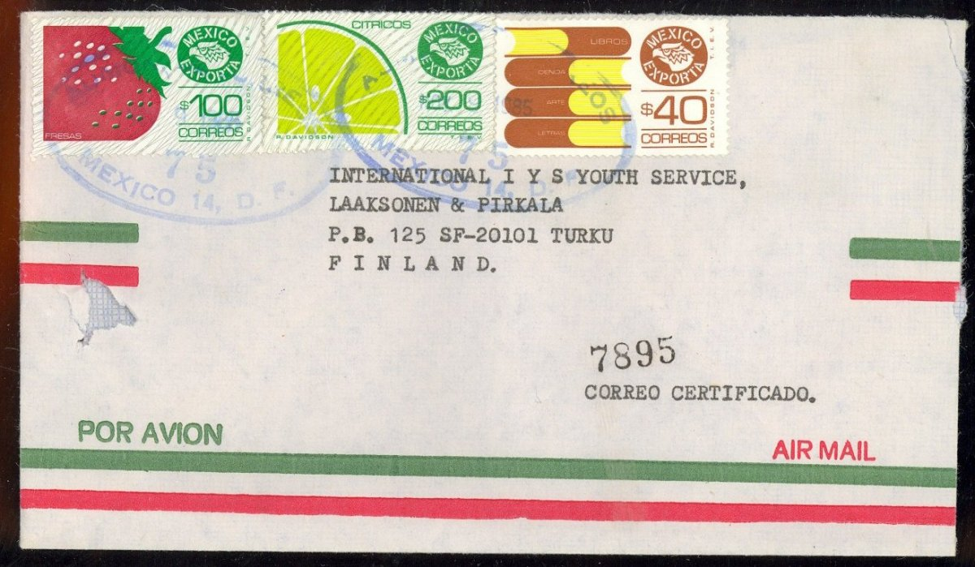

This cover looks ordinary enough. But it is a 9 Nov 85, T38 (short period), 1x (90p) Registered with return receipt (140p) with AR (110p) all adding up to the correct 340p!

To find a correctly rated surface cover, you must find one that does not use any airmail stamps, it is not on an airmail envelope, and does not have “air mail” or “via avion” written on it. Then make sure that it is the correct rate. The best is when the cover is clearly intended for surface. This cover is the perfect example. The sender went to great lengths to cover up the airmail stripes on the envelope and also wrote “via superficie” on it. I have lots of covers that arrived without postage due paying only the surface rate on air envelopes, so Miss Eugenia Ortega did not need to go through all the trouble but she did.

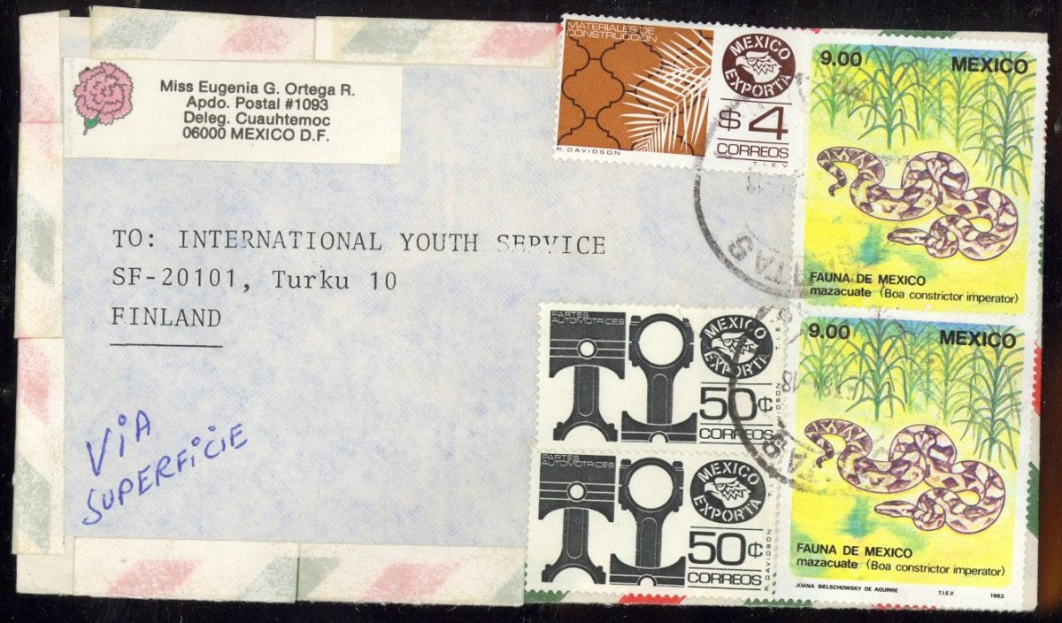

23p pays <20g surface rate! Manuscript "Via Superficie" on Set 84 T36 cover to Finland.

#7. Post Card Rates. I should save the best for last, but the chart is here, so I will let the cat out of the bag. It is crazy, but I am beginning to believe the most underrated achievement in Exportas would be to collect a set of properly rated Post Cards. At the beginning of the Exporta period, there was a discounted post card rate that existed until T34. From then on, until T45 the post card rate was the same rate as the international rate (to the same continent). So there are 10 interesting post card rates to find between T29 and T48. I have examples from only 4 of them, and I have hundreds of post cards with Exportas. A set of correctly rated international post cards may be the toughest challenge of all. Only one of them is relatively easy, the 2.5p T31 rate. The rest are hard, making obtaining a complete set an admirable goal. Why are they so tough? Some of the rates, though lower make little sense given the stamps that were available. There was never a 1.5p or 13p stamp. The 9p stamp did not appear until T36 so could not be used in T33.

Some of them like the 5p should be easy, but then again T32 was a very short rate, and the regular rate was 14p, so maybe people didn’t think or know about the rate. That would make sense, if most of the people who used the post card rate were tourists and just used the regular rate to mail a post card. If it took 2 or three stamps to make a correct rate, on a postcard with just a little space to place the stamp, I could see why people would not be bothered. Still it makes for a very unlikely challenge. I am a long way from putting a set together myself. Yikes! And no need for an image on this one. You can picture it yourself.

#8. Destinations. Obviously, Finland is not as hard as it used to be, but there are lots of countries, or just plain continents that are really tough. Any Africa or Asia destination is tough. Oceania and the Caribbean are harder. Here is a list of countries where I have or know of only one Exporta cover sent to it.

Bahamas, Belize, Bolivia, Bulgaria, Cape Verde, China, Curacao, Greece, Hong Kong, Iraq, Isle of Man, Kiribati, Kuwait, Lithuania, Macau, Nicaragua, Norway, Poland, South Korea, Tanzania, Tonga, and Zimbabwe. I have been collecting foreign destinations for a long time, so while others may have these destinations in their collections, they are just hard to find. Others who collect exportas have other tough destinations like Togo, Czech Republic, Vatican City, India, Vietnam, and Gaza. One of my StampAuctionNetwork friends found a cover to Mongolia for me just a couple months ago. That was also a first.

#9. Postage Due and other Auxiliary markings. I have found a number of postage due covers in all kinds of varieties. This is where the fun begins! I have found a “Screwworm Eradication” marking – I am sure a comfort to the one that received it, and no laughing matter. I have several different examples of Missent mail including “Missent to Jakarta” and “Mal Encaminado a El Salvador”. I have a “This mail was X-Rayed” cover. This one jumps out at you to advise you that the mail was suspended. Since I worked through the IYS correspondence to Mexico, I have also worked through 10 other countries, some 500,000 covers from Egypt, Morocco, Tunisia, Algeria, Indonesia, South Korea, India, Pakistan, Bangladesh and Germany. It is interesting to note, that where in each of those countries, postage due covers are scarce but I would find 100’s out of 100,000’s, but in Mexico out of 20,000 covers, I found only one postage due cover. I would suppose that with all the rate changes, Finland just was not about to figure out if they were shortchanged.

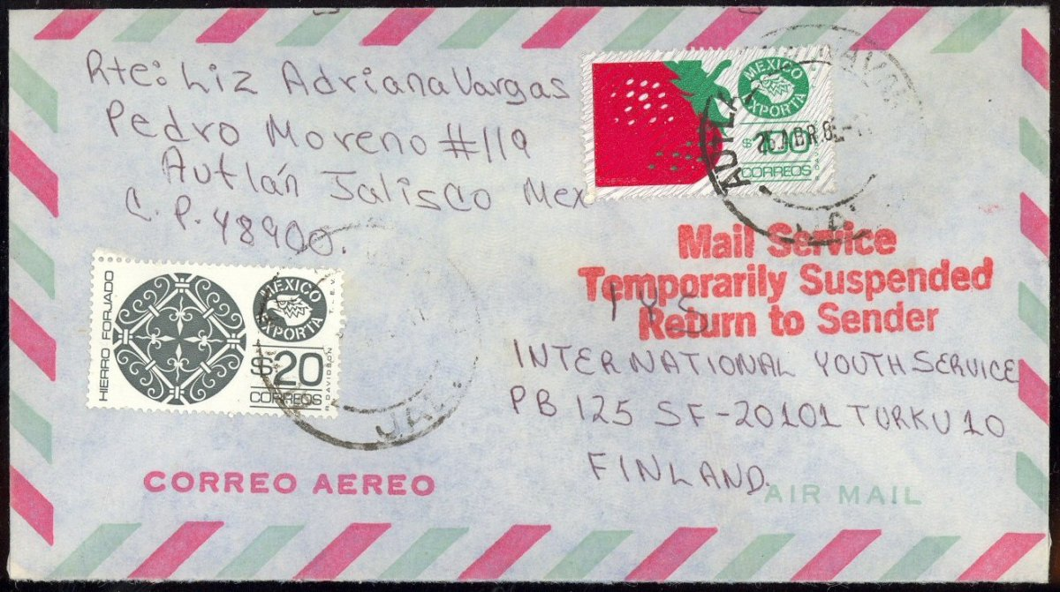

120p overpays T39 110p 1x rate. "Mail Service Temporarily Suspended Return to Sender" auxiliary marking.

10. <20 - <2000 Graduated Rates. Starting with T39, rates began to be calculated based on graduated rate charts instead of straight multiples of 20 grams. To work these out, I make a small spreadsheet for each Tariff with the rates for each weight. Then I don’t have to compute all the combinations in my head. I can look at a cover, add up the postage and then figure out which combinations work.

The further down you go from the top left hand corner, the harder it is to find an example cover. A lot of rounding goes on in the later rates, so finding anything with an odd number is hard.

 | Rates Based On… |  |  |  | Calculated Combinations
T45 | Airmail | Reg | Reg² | AR | Airmail | Reg | Reg² | Reg/AR | Reg²/AR
<20 | 1700 | 3100 | 4000 | 3100 | 1700 | 4800 | 5700 | 7900 | 8800
<100 | 4800 | 3100 | 4000 | 3100 | 4800 | 7900 | 8800 | 11000 | 11900
<250 | 10400 | 3100 | 4000 | 3100 | 10400 | 13500 | 14400 | 16600 | 17500
<500 | 20000 | 3100 | 4000 | 3100 | 20000 | 23100 | 24000 | 26200 | 27100
<1000 | 36900 | 3100 | 4000 | 3100 | 36900 | 40000 | 40900 | 43100 | 44000
<2000 | 65600 | 3100 | 4000 | 3100 | 65600 | 68700 | 69600 | 71800 | 72700

Rate Table for T45 to Europe showing total postage for Airmail, Registered, Registered with Restricted Delivery, Registered with AR, and Registered with Restricted Delivery and AR. The rates highlighted in yellow indicate that I have a cover at that rate.

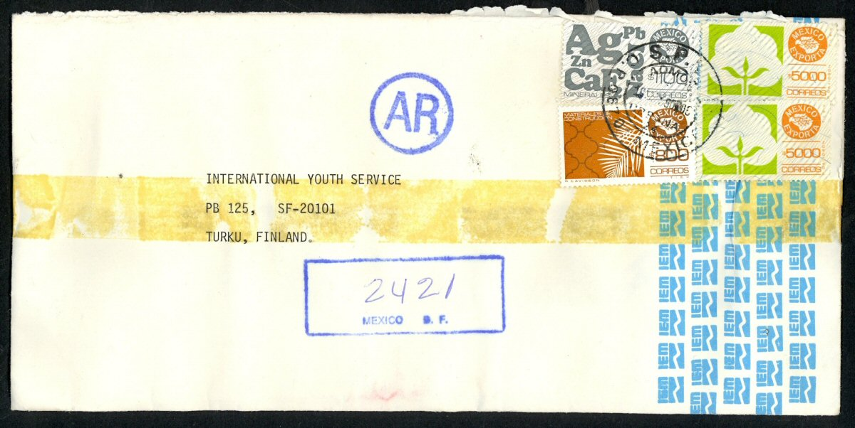

11,900p pays T45 <100g (4800p) Registered with Restricted Delivery (400p) AR (3100p) rate!

So those are my top 10, “hard to handle” collecting objectives with the Exportas. I still need to fill in the correctly rated post cards, and I have Zero covers that intersect some of the top 10. For instance I have no covers that combine a tough denomination with a short rate period. A dealer friend of mine told me once that 95% of the dealers snub their noses at modern postal history. That is good news to me. I am glad that Exportas are still cheap and hard to find, especially any of the ones on this top 10 list!

References to the IYS correspondence refer to the 20,000 cover accumulation of covers sent to the Pen Friend Clearing house (International Youth Services) in Finland. This was the subject of my previous Jan 2015 article in Mexicana.

I will be continuing to post a number of covers at my website. You can review other covers there (join stampauctionnetwork to see the complete census). There is other information about the exportas there, as well as links to other exporta resources, so if you have a link you would like added, you can send that to me also.

http://StampAuctionNetwork.com/ExportaTop.cfm

Tom Droege is a software developer and auction systems expert, with 25 years of experience in auction theory and business management. He is the programmer behind many stamp auction companies and is the creator of StampAuctionNetwork.com. He lives in North Carolina with his wife and has raised four children. He can be reached by phone at 919-403-9459 or by email tldroege@mindspring.com. I will also be attending NY2016 and will have a booth, so drop me an email if you want me to bring some Exporta or other IYS covers.

