Internet Bidding at StampAuctionNetwork
T:\Inetpub\wwwroot\auctionnet\source\InternetBiddingatStampAuctionNetwork.doc

This document explains how the various options for live bidding at StampAuctionNetwork.com work. They include the following capabilities:

- Watching an auction in progress
- Live Bidding during an auction
- Live Audio feed during an auction
- Internet Auction Manager Console. How the auction firm controls and manages the sale.
- Auctioneers’ Monitor

Watching an auction in progress.

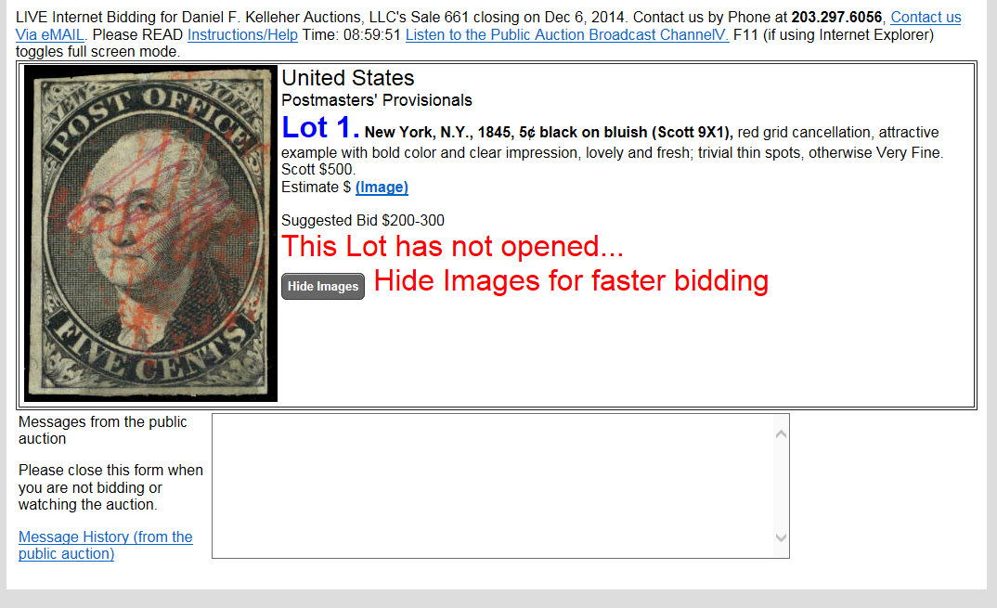

This is for someone who just wants to watch the auction. The screen shows each lot as it is offered, showing the bidding and the winning amount of each lot.
The following are the instructions for bidders who want to participate in a Live Auction at StampAuctionNetwork.com

Getting Started. In order to bid during a live auction, you must be registered with the auction firm, approved by the auction firm and have a paddle number.
- I am completely New to StampAuctionNetwork.com. What do I do? Click "Register" at the top of StampAuctionNetwork, fill out the form, make sure you check the box for the auction firm you want to bid with, wait till you are approved, then go to the table of contents page for the auction you wish to bid in, and pick "Join the Public Auction in Progress".
- I am registered at StampAuctionNetwork.com, but haven't been approved. What do I do? Login at StampAuctionNetwork.com, pick "Update Registration", check the box of the auction firm, wait till you are approved, then go to the table of contents page for the auction you wish to bid in, and pick "Join the Public Auction in Progress".
- I am registered at StampAuctionNetwork.com, but still haven't been approved. What do I do? If you have checked the auction firm and they still haven't approved you, you will have to contact the Auction firm directly.
- I am registered at StampAuctionNetwork.com, approved by the auction firm and ready to go. What do I do? Just login at StampAuctionNetwork.com, go to the table of contents page for the auction you wish to bid in, and pick "Join the Public Auction in Progress". You will be assigned a paddle number and you will be ready to bid.
- How do I turn on the Audio? Once you have joined the auction, you will see a link that says "Live Audio". Just click it. It has its own help file that will explain any problems you might encounter.

Live Bidding at StampAuctionNetwork! Picture in your mind a Public Auction. At the podium stands the Auctioneer. This person sells each lot by taking bids from the auction floor, the bid book (absentee/mail bidders), the phones, and the Internet. Internet bids are handled by the Internet Auction Manager. This person sits at a screen and does several things. First, they push buttons to indicate the current opening or selling price of each lot that is being offered. In addition, they act as an agent and execute the Internet bids.
If you have ever been to a Public Auction, you know that everything happens very fast. Your connection to the "floor", is by the actions of the Internet Auction Manager, As fast as they are, they are always going to be a second or two behind the auctioneer, as it just takes that long to listen and react. For that reason, don't delay your bidding when your lot comes up. You need to let the Internet Auction Manager know that you are interested in a lot by bidding.
Some Advice. Agressive bidding lets the Internet Auction Manager know that you are a serious bidder. You may want to bid a couple increments so that the lot falls to you and so that the Internet Auction Manager sees that you are bidding competitively. In other cases, you can gain some of the advantages of being a book bidder. For instance, if the lot is at $400 and you are willing to go to $500, you can bid $500. The Internet Auction Manager can then bid as your agent, and if the floor goes to $500 and there are no other book bids at $500, they may be able to secure a "Prior 500" bid for you, beating a tie bid on the floor.
Your Browser must be set to Always load a page, and not to pull pages from cache.
In Microsoft Internet Explorer, choose Tools, Internet Options, General, Temporary Internet Files, Settings, "Every Visit to the Page". In Netscape, Edit, Preferences, Advanced, Cache, Document in Cache is compared "Every Time".

Make sure you don't have any old Bookmarks to StampAuctionCentral.com!
In some cases, if you are still using an old link to StampAuctionCentral.com, you will have trouble staying logged in. I can't get this to reproduce on my system, but it did fix at least one person's problem. Replace your bookmark to StampAuctionCentral.com with StampAuctionNetwork.com -- if you are having a problem logging in -- just go directly to http:\\StampAuctionNetwork.com
Bidding at StampAuctionNetwork! You are registered to bid and can bid on any lot by pressing one of the bid buttons. Be Careful when you bid. Watch the lot number to make sure you are bidding on the lot you intended to bid on. Pressing a bid button executes a bid for you immediately. You can not lower your bid. If necessary you can send a message to the auction floor by submitting a message in the "Message to the Public Auction" box. You can send a message if you need to retract a bid made by mistake, or to ask for a lot to be reopened.
The screen will refresh itself based on the refresh rate that you have set. You must be fairly decisive as each lot may only be offered for from 10-20 seconds. You may want to turn off images to speed up your ability to bid. When you bid, the refresh rate will automatically be sped up to just over 1 second. This is to let you know ASAP if you have been outbid. You don't want to wait 5 seconds to be informed that you have been outbid. When you aren't bidding, you can set your refresh to 5 seconds. The refresh can interfere with your ability to press a bid button (the screen can be refreshing right underneath your mouse), so be careful. If you watch the button, you will be able to tell if it was actually "pushed". When your bid has been received, the screen will tell you what you are bidding. Unless you see "your bid" update, your bid has not been received by SAN.
Bid Promptly! Bid what you are willing to pay for the lot as quickly as you can! The floor can move very fast, and your bid will let the Internet Auction Manager know that you want this lot.
Use the PASS Button! When you do not want to bid any higher, please press the Pass button. That lets the Internet Auction Manager know that you will not be raising your bid on this lot. You can still be winning the lot -- but you are telling the Internet Auction Manager that you don't want him to wait for you to bid again if the bidding goes higher. Pressing the PASS button slows down your refresh rate to 2 seconds. Next time you bid your refresh rate will speed back up. You can pass on a lot when you are the highest bidder. You are still winning the lot. If you change your mind and the lot is still open, you can jump right back in on the lot. Don't wait till the last second, though, as the Internet Auction Manager will have thought that you were not interested in the lot.
Don't use the RETRACT Button unless you make a mistake! If you pressed the wrong bid button in error, you may retract your bid. The auction firm has a record of all your retractions, and probably will limit your bidding if they suspect you are retracting your bids for any other reason than an honest mistake. You have been assigned a Paddle Number. The auction firm uses this to identify you as a bidder during the public auction and to award the lot to you. Paddle numbers change from sale to sale. Since you are an Internet bidder, your paddle number starts with an "I".
When you enter the "Internet Floor Bidding" module, lots will appear to be bid on as they come up for auction on the real "Public Auction Podium". Here you can only bid on the lot that is currently offered. Some auction firms will allow you to continue to bid on upcoming lots. To do so, return to the table of contents and bid as normal.
If your bid is not received before the auction house sells the lot to another bidder, you lose. In case of ties, the lot is awarded to the first bid received. If your bid is equal to the selling price and in red, it means that you were the tie bidder, but not the first.
Tie Bids. Your bid is treated as another FLOOR Bidder, not a book bid. If your bid was on the book, your bid would win if it were a tie bid. However, as an Internet bidder on the floor, your bid will probably have the least precedence. It would be wise to bid 2 or 3 increments over the current floor bid amount and give the person managing the Internet bids some latitude in executing your bids.
If your browser seems to lock up. Apparently, Windows Internet Explorer is known to have some "memory leaks". Running it all day long, may cause it to just "lock up". Just close your browser, and start it up again. You will still be logged in, as soon as you pull up the bidding page, you will be right back where you were.
If your screen starts flashing randomly. Sometime the java program that automatically refreshes your screen gets confused and your browser will be pulling images from cache instead of the current ones. You may need to exit your browser and restart it.
Transfer Interrupted! If you get this message, it just means that the java program was trying to get a refresh (it does this every 2 seconds), while another page was coming down. Don't do anything, the proper page should appear in just a second or so.
This is what the bidder sees during the online bidding.
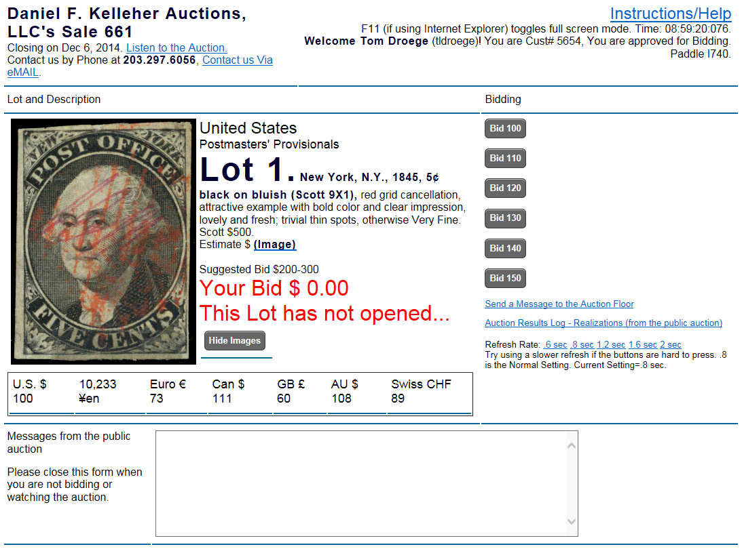
Please note that this snapshot was taken after a lot had been sold. When the lot is for sale, it will say “Selling to another bidder for xxxx”, or “Selling to you for xxxx”.
They can bid instantly by pressing any of the buttons on the right.
They can send a message to the Internet Auction Manager.
They will know clearly whether they are winning or losing a lot. Including if they are the winning tie bidder. At SAN, lots can easily be reopened for bidding.
They will see the history of previous lot realizations as it scrolls on the screen.
They can turn on or off the audio.
A Pass or Retract button will show up if they are bidding on this lot.
Note: The current version of the bidding software uses JAVA and AJAX technology to keep the screen from “flipping”. The screen will refresh every second without a flicker.
Turning on the Live Audio.
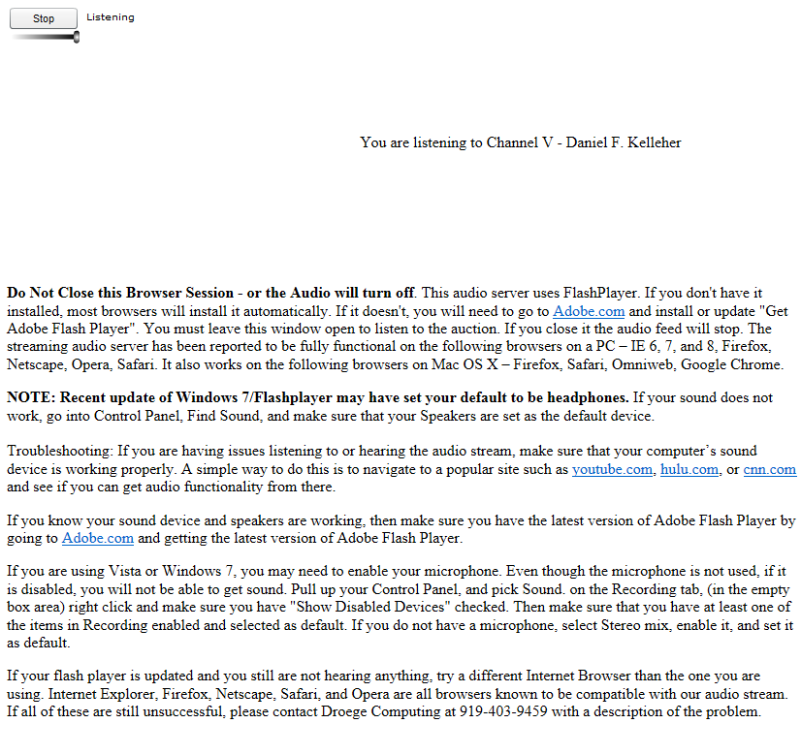

This is the screen the bidder will see when they pick the “Live Audio Feed” link on your table of contents page, or your Bidding Screen.

Live Audio requires the installation of an ActiveX control, and requires the use of Windows Internet Explorer. They can minimize the form when it comes up, but if they exit the form, the audio feed will be dropped.
THE AUCTION MANAGER CONSOLE

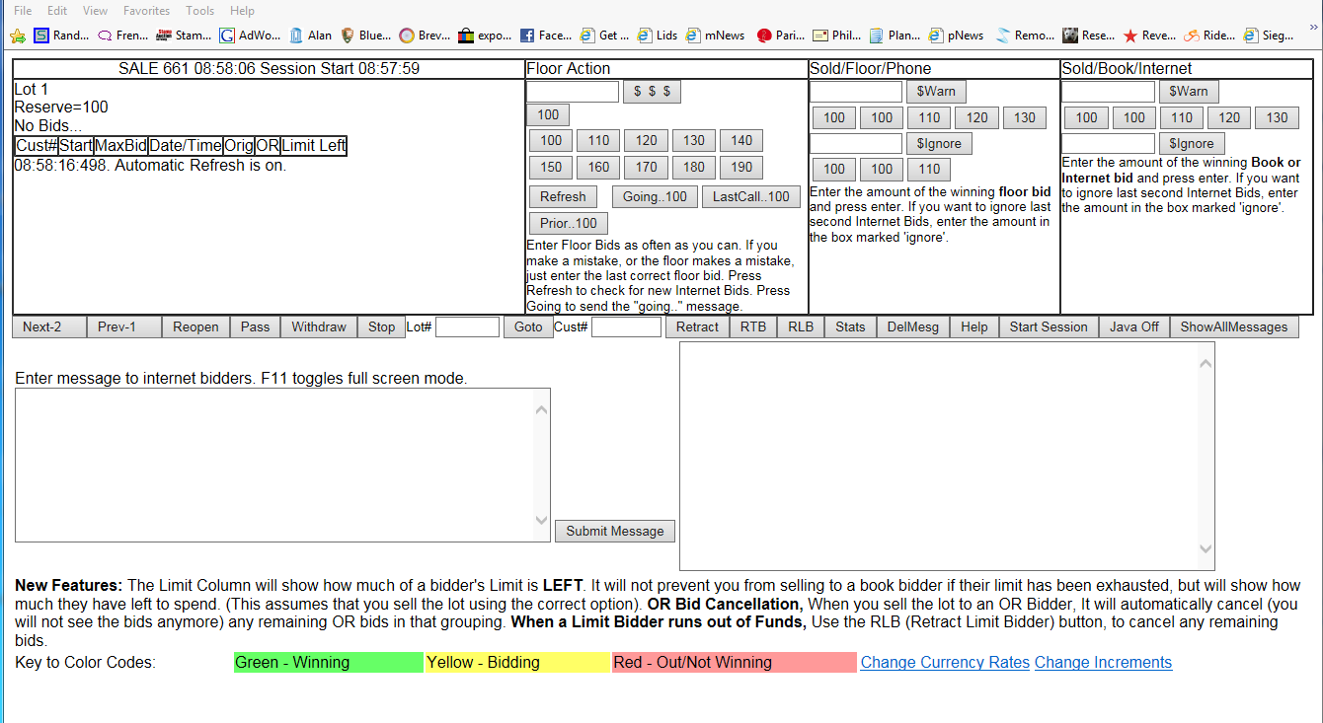

Starting Up. You need two accounts, one your administrative account which was assigned to you and a regular StampAuctionNetwork account for which you have gone through the regular registration process AND selected YOUR OWN firm to bid with. Then you must approve yourself for bidding.
You must be logged in -- both as an administrator by going to your administration page and logging in, and as a user. To get started, you must first login to your Admin Account, then login as a bidder and then go to your table of contents page.
From your table of contents page for your auction, you will now see "Manage the Auction", pick this option to control the public auction. You will only see this option if you are logged in as an Auction Administrator.
As Manager of the LIVE Internet Bidding, you have 2 main responsibilities.
- Communicating the activities of the floor to the Internet Bidders. As each lot is offered, you must try to enter the increments into the "Floor Action" field. Do not worry if you miss increments. As you do this, the Internet bidders will be able to tell where the floor is... Any number you enter becomes the "Floor" so if you make a mistake, you can easily correct it by entering the correct amount. When the auctioneer calls "going...", you hit the "going" button. When the item is sold, you enter the amount the item was sold for in the "Sold/Floor" field and press enter. When you do so, the program will move to the next lot (unless there is a Internet Bidder - see below).

- Bidding as Agent for Internet Bidders. Your other main job is to bid for the Internet bidders. This is done by watching the first box with the bidding information in it. You only worry about "Internet Floor" bidders. The program assumes that any prior bids entered via the Internet have been placed in the bid book and the Auctioneer is bidding for them. (LATE Bids in Green is an exception to this and described later.)
If the bid is in GREEN, it means that a bidder participating as an Internet LIVE bidder is the high bidder on this lot.
When you have more than one Internet Bidder that is winning. The Internet bidders will be bidding against each other. You must announce the winning bid amount to the Auctioneer. The Auctioneer will then call out, "Selling to the Internet for X". That is not a floor bid. If you press one of the floor bid buttons, the Internet Bidders will think they are being out bid by the floor and that they are losing the lot. Press the "Going" button next to the Winning Internet bidder amount.
As you bid as agent, if the floor is also active, you must keep entering the floor activity so that the Internet bidder will know that they must keep bidding if they are topped. If the Internet Bidder wins, you give the Auctioneer the Paddle number (starts with "I") of the Internet bidder and then you record the amount the lot was sold for in the "Sold/Book/Internet" field. They should already be registered, as we ask all Internet bidders to check into the sale and get a paddle number, otherwise you can register them on the fly by providing their customer number. If you are not keying results immediately, you might want to jot their customer number down. You only need to record the customer number once for each "I" paddle number.
The General Flow of things. The clerk or Auctioneer calls out the opening. You enter the opening as one of the Floor Bid entries, either by picking one of the bid buttons, or by typing it in. Then you keep pressing the floor bid buttons, when you hear "Going", press the "Going" button, when you hear "Last Call", press the "Last Call" button. Then sell the lot to either the Floor, or the Book/Internet. It will then go on to the next lot.
If you try to award a lot to the Floor and an Internet Bidder is still high bidder, the system will give you the "Last Minute Bid Received" message, you can either notify the auctioneer that you have an Internet bid, or you can override this message and sell it to the floor by entering the amount in the box marked "ignore".
An Exception would be where bidders continue to place regular Internet bids on upcoming lots via the Internet. They are allowed to do this. Suppose you are on lot 100 and an Internet bidder bids on lot 150. You are not going to stop the auction and place those bids in the bid book. When lot 150 comes up you will see the bid for the Internet bidder. You will need to bid as agent for this bidder. If you had set the “Start Sesssion” button at the beginning of the session, this lot will be highlighted in Green and noted as a “LATE BID”. You must bid for this bidder just as if he was a LIVE bidder.
The Sale Box. The first box contains the Lot number offered, who it is offered to, and a table containing the bids for this lot. "IB" is a bid entered at SAN. "Internet" is a Live Bid. "Floor" is the bid you enter to indicate the floor level. Bids will be color coded to help you identify winning bidders (green), bidders who are within 80% of the winning bid (yellow) and bidders who have passed (red). You must bid for the winning internet bidders. When a button shows up in this box, it is because the Internet Bidder is winning. If you have more than one winning Internet bidder, you will need to use this button instead of the regular closing button or Floor Bid buttons. (Do not use the Floor Bid buttons to announce competition between two Internet bidders -- The floor bid button is only for Floor Bids.)
Floor Action. The second box contains the buttons that you press to tell the internet bidders what the lot is selling for. You can key an amount, or pick one of the buttons. Follow the rythm of the auctioneer. Every time you press a button the bids will be refreshed so that you can see any internet bidders. As long as you are using the "Going" and the "Last Call" button, you should be able to see the internet bidders. Keep up as best you can. Don't delay after hearing "Last Call" and selling the lot, or the bidders will think the lot is still open. Don't hit "going" as a way of refreshing the bids, as that will only teach the bidders that they can ignore the "going" message.
The Sold/Floor Box. Use this section to sell a lot to the floor. Click the button that contains the selling price, or type it in. If a bid sneaks in before you sell it, you will be warned. You can ignore it by entering the amount in the $Ignore box. You must type the amount in and then press "$Ignore". You will get the warning message if you try to sell a lot and there is a higher bidder. Sometimes, you will have OR or Limit bids still on the Internet that have been cancelled by the auctioneer. You will have to use the "$Ignore" in these cases.
The Sold/Book/IB/IF Box. Use this section to sell a lot to the Internet or Book. Click the button that contains the selling price, or type it in. If a bid sneaks in before you sell it, you will be warned. You can ignore it by entering the amount in the $Ignore box. You must type the amount in and then press "$Ignore". You will get the warning message if you try to sell a lot and there is a higher bidder.

Step by Step - How to Start the Public Auction Live Bidding
1. Login to the SAN Admin Page (use a bookmark or make one if you don’t have one)
User Name_______________ Password _____________
https://stampauctionnetwork.com/admin/Admin_login.cfm

2. Start the Public Auction Audio Broadcast. Follow the Link at the admin page that says Start Public Auction Broadcast, and Press the Online button. Do not close the Audio form. It will turn off the audio.

3. Go to the main StampAuctionNetwork.com Home Page (use a bookmark or make one if you don’t have one) - Login as an approved bidder. Enter the user name and password of the approved bidder below.
User Name_______________ Password _____________

4. From SAN, follow the links to the table of Contents page of the auction you will manage and pick "Manage the Public Auction in Progress"

Note to the Auctioneer.
During the auction, you should use your microphone to talk to your Internet audience to encourage good bidding behavior. Ask them to place their bids quickly. Ask them to use their PASS button when they are topped out and will not bid any more as that will speed up the auction. A pass bid is still a winning bid, it just indicates that they are not going to bid anymore.

Running the Auction
- Start Session. Press [Start Session]
Before the auction you will have been downloading bids and entering them into your backend system. These bids are “book bids” and appear on the “auctioneers’ book”. Generally, the auctioneer bids as agent for these bidders. You will also see these bids in the console. You will not bid for those bids. However, during the auction, bidders may still navigate the auction catalog and place “book bids”. This does not happen a lot, but it will happen. The purpose of the Start Session button is to allow you to distinguish between these bids and the bids placed before the session started (which would be in the auctioneers’ book). You should press the Start Session button at the beginning of each session, after you have downloaded any book bids from SAN and put them on your book.

- Enter a Message, and press [Submit Message]
This is where you should put messages like when the auction will start, when you are taking a break, when you are planning to resume the auction.
- Make sure you are at the first lot. Press [First] or use the [Goto] to move to a different lot.

- When the lot opens, enter the opening (that the auctioneer calls) amount in the “Floor Action” column next to the $$$, or press one of the floor bid amount buttons.
The opening is the amount that you have or the current selling price. If you open a lot at $100, it means you have $100 and are looking for someone to top it. If you do not have any bids and you want to open it at the reserve, you will have to open it at an increment below the reserve if you are willing to sell the lot at the reserve.

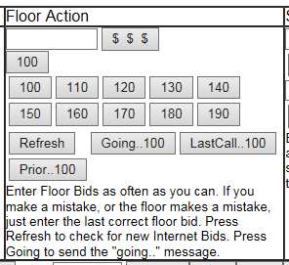
- Press the Floor Action buttons whenever (and only when there are bids from the floor). Correct errors by typing in the correct floor bid amount in the [$$$] button. If you get behind the auctioneer, just press the button for the last floor bid that was called.
IMPORTANT: Only press Floor action for Floor activity (including the phones and the book). When the auctioneer declares the bid is going to the Internet, you DO NOT press floor action. If you do, the Internet will think the lot is selling to the floor. If you press a Floor Button when it was the Internet bidding, you will need to correct your mistake immediately, by entering the last floor bid in the $$$ box.
- Watch for incoming bids in the “Sale” column. You must bid for the winning Internet Bids in Green, using the amount shown. You will see the total amount of their bids in the bids grid. They often give you more than is needed. If the floor outbids them and they have more, do not wait to bid for them again, just call out “Bid”.

- You must also bid for any bids marked [Late Bid], these are bids entered at SAN by browsing the catalog (as entered pre live auction) or by updating their bids in “My Bids”. They won’t be on the auctioneers bid book and they are marked as Late bids because they are time stamped after you pressed [Start Session].

- When you see an Internet bid in Green, press the “Going” button by the green Internet bid. If/When they are out bid, press the Floor Action button and immediately look back to see if they have bid enough to be the top bidder again.

- You do not need to hit refresh. Incoming bids will get refreshed automatically every second.

- Hit the [Going] button when the auctioneer calls it.

- Hit the [LastCall] button when the auctioneer calls it.

- Hit the [Prior.. ] if you want to send a clear signal to the internet bidder that the auctioneer took either the floor or the book instead of the internet, and that they need to bid again.

- If the lot sells to the Floor or Phone, you must sell the lot to the Floor by using one of the Sold/Floor/Phone Buttons. Try to press this button as quickly as you can after the auctioneer sells the lot. The Internet bidders can keep bidding on the lot until you sell it – so you want to press the sold button as promptly as the auctioneer calls it.
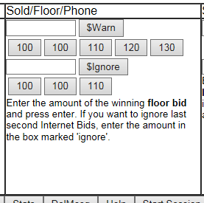
Normally, you will use one of the top sets of buttons (the first row after [$Warn]). This option will first check to see if there are any last second bids from the internet and then sell it. If there was a last minute bid, it will give you a warning that there was a last minute bid. The lot will not close. You would instruct the auctioneer that you have a last second bid, and ask for direction. Does he want to keep it open or close the lot. If he keeps it open, you do nothing, he will take the internet bid and continue. If they deem it too late, then you must sell the lot using one of the $Ignore buttons. It will put a message in the log that their bid was too late.
- Sell the lot to the Book or Internet by using one of the Sold/Book/IB/IF buttons. The Internet Paddle will show up before you sell the lot in the “Sale” section, and after you sell it in the message section.
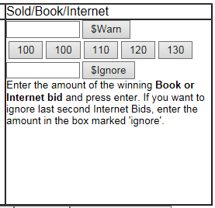
If you are selling it to the Internet the auctioneer will want to know the paddle number that you sold it to. Again, if you have a last minute bid, the lot will not sell and you will get a warning message. Normally, you would always keep the lot open at this time, just proceed until you have a clear winner.
- If last minute bids come in while you are trying to sell the lot, it will not let you sell the lot. You will get a message and the Internet bidder will be winning. You must alert the auctioneer that you have a late bid. If the auctioneer takes your bid continue as normal. If not, you must sell the lot using the $ignore button. A “Sorry your bid did not reach the floor in time” message will appear.

- You can reopen a lot after selling it by, [Prev-9999], [Reopen]. Make sure you press [Prev-9999] first.

- You can go to any lot by using the [Goto] button.

- Keep watching the Incoming messages section. This is very important, as this is where bidders will send you messages, and more importantly, this is where you will get messages from Droege staff if we notice something going wrong. The messages are only refreshed when you move from one lot to another. So if you are having difficulties, press the [Refresh] button. We may be trying to send you a message while we monitor the sale.
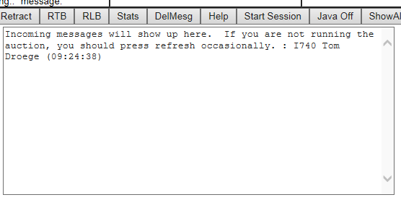

If we send you a message and you get it, and then you call out from the podium to talk with us, we will hear you and we will reply using the message system. But if you do not press the refresh button you will not see the message.

- There are more options which should be gone over in the training outline at the end of this document.

Other Options
- Next. Moves you to then next lot.
- Prev. Moves you to the previous lot.
- Reopen. Reopens the lot for bidding. Sends a message to the Internet Bidders.
- Pass. Closes the lot at 0 selling price and stops bidding on the lot.
- Withdraw a lot. Sends a message to the floor that a lot was withdrawn.
- First. Goes to the first lot in the sale.
- Lot#. Go to a selected lot in the sale.
- Retract. Occasionally an Internet Bidder will misbid. You may get an urgent message -- retract my bid! Enter the customer number of the bidder and their bid will be set to 0. You will still be able to see this bid, since you have set the bid amount to Zero.
- RTB. Retract Top Bid Use this button when the top bid is a Limit or OR Bid and you want to eliminate it from consideration. The bid amount will not change, but the lot will be ignored for all calculation and awarding purposes. (Note: if you need to retract a bid that is not the top bid, use Retract and enter the customer number).
- RLB. Retract Limit Bids Use this button when the top bid is a Limit Bidder and you want to eliminate this bid and all remaining limit bids, as the bidder has run out of money. Those bids will be ignored, but they will not be changed.
- Stats. Gives you some interesting information about the Internet Bidders.
- DelMesg. This deletes all the incoming messages that you see in the First Box below. These are messages sent by the Internet Bidders to you via the "Send Message" option found in "Join Auction"
- Help. Gets you to this page.
- Submit Message. As the auction progresses, certain messages automatically go out to the Internet bidders. Up to 10 lines are kept open. You can clear out these messages by editing the box and pressing "Submit Message". You can add your own message etc. Remember, the Internet Bidders only see what you see.
- Late Paddle Registrations: An Internet bidder can get an I Paddle after the auction starts. You can register his paddle on the fly by giving the clerk the customer number.
- SetNextPrev. Don’t use this unless the Next and Prev buttons do not have the lot numbers.
- Start Session. Press this button, just after the last synchronization before printing the bid book. Its purpose is to mark late bids on the Internet as "LATE BID". A Late Bid would then be one that would/might not be on the Auctioneer's bid book. (If you using the AMS program to pull opening and book bids -- then you would see any bids downloaded from SAN on the Floor Bids Module). IE. Shreves, press the Start Session after each time Cindra synchronized during the sale, as Charles will see the bids that were downloaded, but not the late bids after the download. Siegle. Press the Start Session at the beginning of each session, as Scott will not have any late Internet bids on his bid book and the Internet Bid Manager will need to bid for them when the book stops bidding.
- Message Area 1. To the Internet Bidders.
- Message Area 2. From the Internet Bidders.
Miscellaneous Notes:
- Sometime you will get a message when selling that the bid has been received after the closing time for this lot. The closing date and time may not have been set far enough out to allow you to sell the lots during the public auction. You will have to reopen each new lot after selling the previous.
- Splice Bids. You can enter any number as an opening or current selling price. If you enter a number that is not in valid increments, it will open at that amount. The bid increments will be determined from that amount and will also be out of increment. Use the Floor Bid entry to get the increments back on track if the spliced bidder was outbid.
Here are two things they should always do at the beginning of a session to keep it from freezing up.
1. Make sure they have the cache setting correct.
Your Browser must be set to Always load a page, and not to pull pages from cache.
In Microsoft Internet Explorer, choose Tools, Internet Options, General, Temporary Internet Files or Browsing History, Settings, "Every time I Visit the webpage". In Netscape, Edit, Preferences, Advanced, Cache, Document in Cache is compared "Every Time".
2. Also, They should delete temporary files each time you start a session.
Tools, Internet Options, General, Temporary Internet Files or Browsing History, Delete, Termporary Internet Files, Delete Files.
- If you run into real problems, try deleting all your temp files, cookies, and history.
Tools, Internet Options, General, Delete, Delete All

The Auctioneers’ Monitor

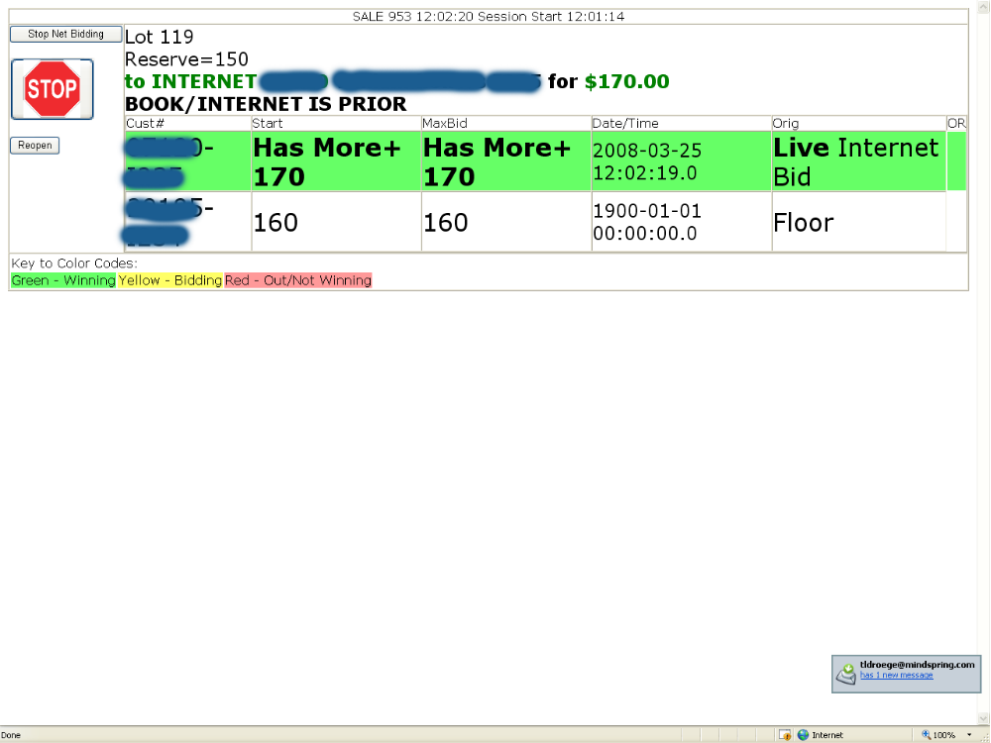

This monitor is designed for the auctioneer’s podium. They can easily watch the incoming bids, see winning bids in green, potentially active bidders in yellow, and passed bidders in red. They also see all the bids on the book, so they can see late internet book bids. Although, generally, the Internet Auction Manager is executing bids for the internet bidders, this is extremely helpful to aid in running the auction, and for waiting for the internet at appropriate times. If you have a touch screen, the Auctioneer can also close the auction to the internet if they find that you have late bidders that are keeping the auction open.

Training Outline.

SAN ADMIN PAGE
- Get them to the Admin Page
- Bookmark it.
- Print out the Help File, write down User Name, Password.
- Locate their Bidder Account, login and Update Registration to make sure they are to be registered.

STARTING THE AUDIO
- Start Public Auction Broadcast – Wait and Allow
- Test Listen to Auction Broadcast

SAN ADMINISTRATION
- Print out the Bad Bidders List
- Take them through all the Synch processes

LIVE BIDDING
- Admin Page – Admin Login
- Login as a User/Bidder
- Goto the TOC Page
- Manage the public Auction in Progress
- Write down Admin/User Login Steps to start Internet Auction Manager Console

PRACTICE
- Starting the Auction – Pressing the Start Session
- Starting the Auction – Entering a message
- Keep up with the Floor/Telephone/Book Bidding – no Internet bidding.
  - 20 Lots
  - Open the Lot
  - Auctioneer - Run the lot up
  - Using the Floor action section, press the correct buttons as you follow.
  - Use the Going button
  - Use the Last Call button
  - Sell the Lot using the “Sold/Floor/Phone” section
  - After doing 20 lots practice fixing errors, open the lot at a lower amount. Back up if you take the floor too high, by using the $$$ entry.
- Introduce one Internet bidder
  - 20 Lots
  - Auctioneer open up the lot and run it up
  - Bids via Internet
  - Train auction console operator to bid for the internet.
  - Talk with Auctioneer about how to communicate to the Internet. Use terms like “selling to the floor”, “It is against the Internet”, “With the Internet”, etc…
  - Explain the color codes of the bids – Green Winning – Yellow Bidding within 20% - Red Not bidding any more.
  - Teach the operator not to reveal the total bid when the bidder gives them more, but to use that information to rebid quickly for the internet. The amount to bid is shown in GREEN at the top of the 1st box, where it will say selling to “bidder” for $amount.
  - Press the Going to the Internet button when the Internet bidder is winning.
  - Teach the operator not to use the Floor Action button when they hear the Auctioneer call “selling to the internet for $”
  - Correct the above problem by entering a floor bid amount less than the internet bid.
  - Sell some lots to the Internet. Train on how to announce the winning paddle to the auctioneer.
  - Sell some lots to the Floor
- Last Minute Internet Bidder
  - 10 lots
  - Same as before, except bid via Internet when you hear the auctioneer sell the lot.
  - You must simulate “Last Minute Bid received”
  - Options – keep the lot open – do nothing
  - Sell the lot to the floor – using the $Ignore button
  - Explain that $Ignore means “Sell the lot and Ignore the message that tells you there is a last minute bid”
- Late Bid Examples
  - Using the catalog entry enter some bids on upcoming lots.
  - Explain what a LATE Bid looks like (in green), LATE BID and that they must bid for them just as if they were a live internet bidder.
- Competing Internet Bidders.
  - Allow more than one internet bidder to bid
  - Run up the lot
  - Train operator to announce the current selling price to the auctioneer.
  - Sell the lots to the Internet
- Correcting the problem when you press the floor bid when you didn’t mean to. You enter the correct last floor bid amount.
- Dealing with Splice bids. Do not enter the splice, enter the last bid as a floor bid. Example, Internet was winning at 400, floor asked for a splice of 405, Press the 400 Floor Bid, then the Internet will know they are losing, and that they need to bid 425.
- Reopen a Lot, Goto (or Previous), Reopen, Sell it, Goto. The key is that you must get on the lot first before you can reopen it. And that you must Reopen it before it will allow bidders or the operator to bid.
- Clear Agent Bid, Prev, Reopen, Sell it. (however, this is not really necessary if it slows you down-the amount will get fixed later when the prices realized are loaded after the audit)
- Enter Wrong Floor Amount, Put in Correct Amount
- Filling in messages.
- Pass and Withdraw a lot

NOTES
- You continue to Synchronize during the sale, that gets last minute bids, new paddle registrations, etc..
- You should make sure that the Internet Paddle List printed at SAN matches the Paddle List on AMS.

